Direction of Code Running

# Simulated Data

This simulator includes four attack moles, i.e. Attack Model A: Independently Malicious (isolated), Attack Model B: Chain of Malicious Collectives (collective), Attack Model C: Malicious Collectives with Camouflage (disguise), Attack Model D Malicious Spies (spy). Next, we detail how each attack model is performed to get the results as reported in paper M2MTrust.

1. **Attack model A**
   1. **Several Key Settings**

(1) The concrete parameters are set in Class TraceGenerator. The ratio of malicious peers (USR_PURE) varies from 0 to 70%. The WARMUP can be modified proportionally as the number of total transactions varies.

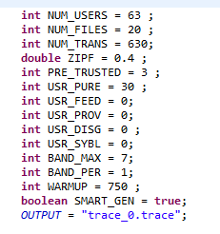

(2) The ratio settings of files owned by malicious peers are as follows in Class GeneratorUtils Package generator_lib.

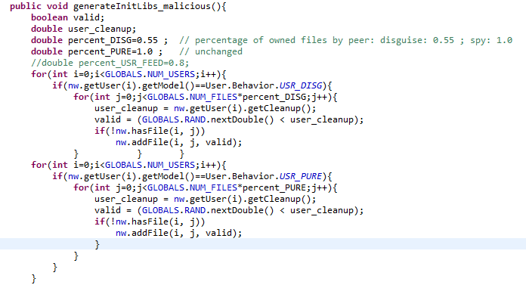

(3) The number setting of files owned by good peers is as follows in Class GeneratorUtils, Package generator_lib.

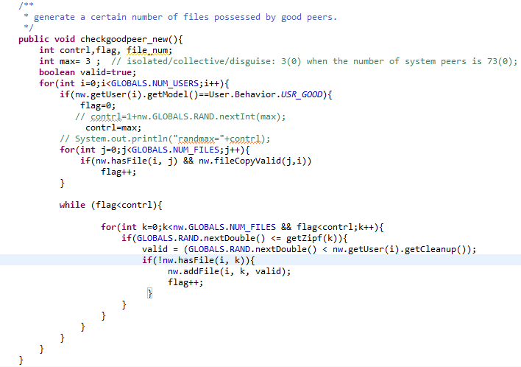

(4) The cycle of computing trust scores is set as follows in Class TraceSimulator. However, the cycle can be modified proportionally as the amount of total transactions varies.

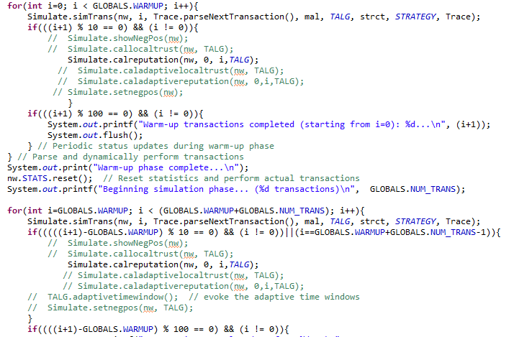

1. **Attack Model B**

All the configurations are similar as Attack Model A.

1. **Attack Model C**
   1. **Several Key Settings**
2. The concrete parameters are set in Class TraceGenerator.

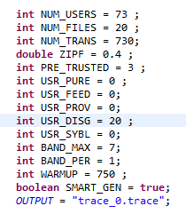

(2) The ratio settings of files owned by malicious peers are as follows in Class GeneratorUtils, Package generator_lib.

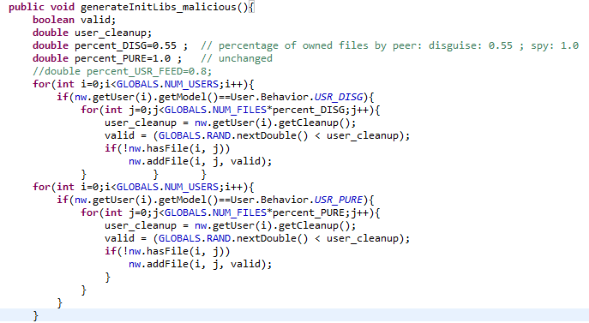

(3) The number of files owned by good peers is set as follows in Class GeneratorUtils, Package generator_lib.

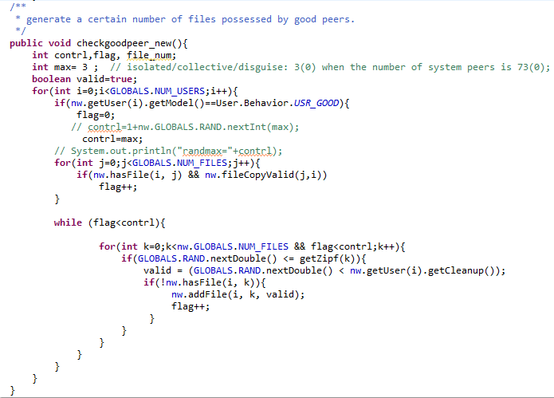

(4) The cycle of computing trust scores is set as follows in Class TraceSimulator. However, the cycle can be modified as the amount of total transactions varies.



1. **Attack model** 
   1. **Several Key Settings**
2. The concrete parameters are set in Class TraceGenerator. Here USR_PURE denotes the type B peers, and USR_DISG denotes the type D peers, which combine with various groups.

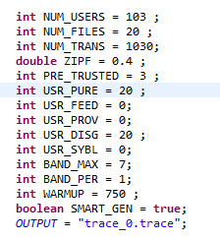

(2) The ratio settings of files owned by malicious peers are as follows in Class GeneratorUtils, Package generator_lib.

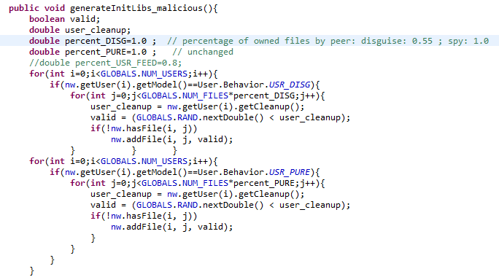

1. The number of files owned by good peers is set as follows in Class GeneratorUtils, Package generator_lib.

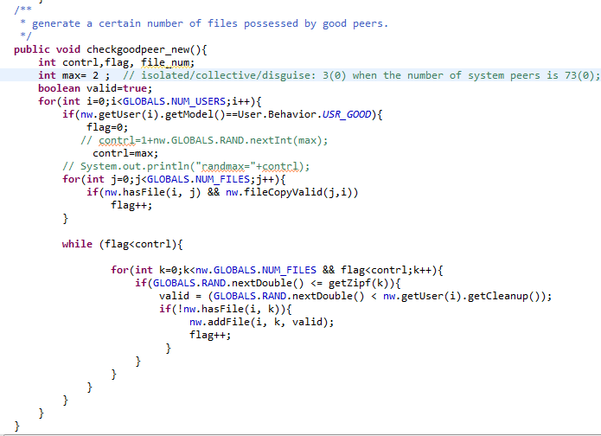

(4) The cycle of computing trust scores is set as follows in Class TraceSimulator. However, the cycle can be modified as the amount of total transactions varies.

